LANDOWNERS GUIDE
TO PLAN & INSTALL
A COST-SHARED
GRASS WATERWAY PRACTICE

WHERE DO I GO FOR ASSISTANCE?

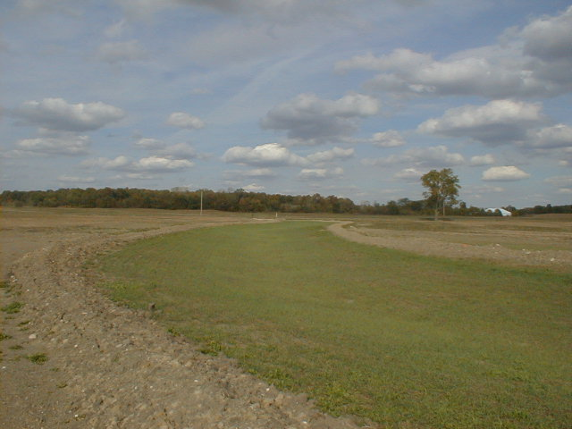

The United States Department of Agriculture (USDA) prohibits discrimination in all their programs and activities on the basis of race, color, national origin, sex, religion, age, disability, political beliefs, sexual orientation, and marital or family status. (Not all prohibited bases apply to all programs.) Persons with disabilities who require alternative means for communication of program information (Braille, large print, audiotape, etc.) should contact the USDA's TARGET Center at (202) 720-2600 (voice and TDD). To file a complaint of discrimination, write USDA, Director, Office of Civil Rights, Room 326W, Whitten Building, 14th and Independence Ave. SW. Washington D.C., 20250-9410 or call (202) 720-5964 (voice or TDD). The USDA is an equal opportunity provider and employer.
Landowner’s Guide to Plan and Install
A Cost-Shared Grass Waterway Practice

Landowners:

If you are experiencing a soil erosion, water quality, or other natural resource related problem on your property, you may be eligible for federal cost-sharing assistance in solving it through the USDA, Conservation Reserve Program (CRP). Several agencies are involved in the cost-share program. This guide is an effort by these agencies to make you more aware of the procedures involved and responsibilities of all parties in processing, designing and completing the project. We recommend you keep this guide for reference, as you step through the process.

The installation of a conservation practice is a worthy goal and we commend you for your interest in preserving and protecting the natural resources of our county. Normally, two United States Department of Agriculture (USDA Farm Service Agency and Natural Resources Conservation Service) and a local agency (the Soil and Water Conservation District) will be involved in financing, surveying, designing and supervising the installation of your project. All services from these agencies are provided free of charge, however, you and they have certain responsibilities.

Project responsibilities:

USDA, Farm Service Agency (FSA) Responsible for financing project through the Conservation Reserve Program (CRP). 419-738-3918

USDA Natural Resources Conservation Service (NRCS) Responsible for engineering, evaluation, survey, design and installation supervision of project. 419-738-4016

Auglaize Soil and Water Conservation District (SWCD) Responsible for working with NRCS to install practice according to their specifications. 419-738-4016

In order to receive cost-sharing, you must follow and complete several official “steps”. Reviewing these steps and checking them off as they are completed will enable you to continually know the current stage of completion of your project. You are welcome to contact the above named agencies for additional information during any stage of your project.

Please note that due to the number of projects being completed at one time, steps involved, and the uncertainty of several other non-controllable conditions (weather, etc), it may require several months from the time of practice approval until the practice is installed; therefore, it is extremely important that you, as a landowner, sign up at FSA (Step 1) and plan conservation project construction at least 6 months in advance of needed completion date. Planning ahead will enable you to arrange crop rotations and farming operations to provide construction space for such projects as waterways. This time period will also allow all agencies involved to do a better job of planning their expenditures and work schedules and enable all parties to be better satisfied with the overall project installation.

Again, we commend you on your interest and wish you many satisfying years of service from your conservation project.
Landowner’s Guide to Plan and Install
A Cost-Shared Grass Waterway Practice (Check List)

SUGGESTION A: Prior to completing Step #1, the landowner should contact the SWCD or NRCS to schedule an on-site evaluation of the natural resource problem. During this visit, representatives of the SWCD and/or NRCS will examine the problem with the landowner, offer various solutions to solve it and suggest that you contact the FSA Office (Step #1) if the practice might be eligible for cost-sharing. This procedure will save agency manpower and paperwork if the proposed practice is not eligible for funding.

X When Completed

- Landowner signs up at FSA Office for CRP (Conservation Reserve Program).
  - Show on map – location of proposed practice.
  - List crop rotation and tillage currently being used on the adjacent fields.

- Landowner receives “Notification of Approval Subject to Feasibility” from FSA Office, and is informed to contact SWCD/NRCS technicians to arrange for visit and evaluation or feasibility of practice. During this same time frame, FSA sends referral or landowner request for cost-sharing to NRCS/SWCD.
  - SWCD/NRCS checks feasibility of practices with the landowner (may have already been completed if landowner followed Suggestion A).
    - Is practice needed?
    - Appropriate for location?
    - Suitable outlet?
  - Calculate gully erosion.
  - Inventory and Evaluation Worksheet with estimated costs is completed.
  - USDA Estimated Cost-Share Assistance Worksheet is completed.
  - Landowner receives copy of estimates (worksheet and cost-share).

- NRCS returns referral to FSA with determinations favorable or unfavorable, and an estimate of cost.

- FSA sends Contract to Columbus for archeological study(30 day time frame)

- FSA notifies landowner of eligibility and sets up an appointment to complete paperwork. Note: A copy of the deed is required by FSA to sign up for the CRP program.

- NRCS, District Conservationist completes the Conservation Plan/Contract Support Document. This plan outlines the amount of proposed improvement and cost-share assistance associated with items to be constructed.

- Landowner signs all USDA forms for cost-share assistance.

- County approvals by agency prior to construction
  - SWCD Board of Supervisors
  - NRCS District Conservationist
  - FSA County Committee

- Signed and approved copies of Conservation Plan/Contract Support Document are mailed to landowner.
- Landowner contacts NRCS/SWCD to survey project
  - Landowner may need to clear area before survey can begin. If so, he will be officially notified by NRCS/SWCD.
  - Special Note: Construction areas must be clear of crops, weeds, brush and other obstacles that interfere with survey. Landowners should plan cropping sequence accordingly, not planting construction areas. Often, this vacant land can be used as FSA set-aside

- NRCS/SWCD surveys site, develops plan, gives two (2) copies to landowner. (This can be a most time consuming process.) Note: Any change of practice or costs must be reported to FSA for consideration of revisions for approval.

- Landowner chooses a contractor (should get two or three bids based on site and plan).

- Meeting with NRCS/SWCD technician, landowner and contractor to review plan.

- NRCS/SWCD stakes out practice.

- Contractor begins construction. Landowner should maintain contact at the time to answer specific questions of contractor (i.e., removal/disposal of brush, spreading of excess oil, location of existing tile lines, etc.)

- NRCS/SWCD monitors construction, making sure all work meets USDA Standards and Specification.

- Contractor completes earthwork.

- Landowner is responsible for seeding/mulching/fertilizer – see Grass Waterway Job Sheet and Engineering Plan.

- NRCS/SWCD makes final check on project – surveys to make sure elevations are as planned, seeding is completed, etc.

- NRCS notifies landowner and FSA that project is complete and that seeding/mulching/fertilizer meets specifications.

- Landowner turns in bills to FSA and is paid for allowable expenses as approved by FSA.

- Landowner maintains practice for contracted life (10 years).

