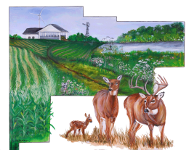
Auglaize Soil and Water Conservation District
110 Industrial Dr #G
Wapakoneta, OH 45895-9231
419-738-4016

The Auglaize Soil and Water Conservation District is accepting sealed bids for the following:

2022 Chevy Equinox - Sold As Is

Silver, AWD, 6 speed Auto transmission, power driver seat w/lumbar, remote start, black cloth heated seats, cruise control, safety assist package includes: following distance indicator, front pedestrian braking, front and rear park assist, side blind zone alert, keep in lane assist with lane departure and forward collision alert. Current mileage = 19,417 but could be higher since still driving.

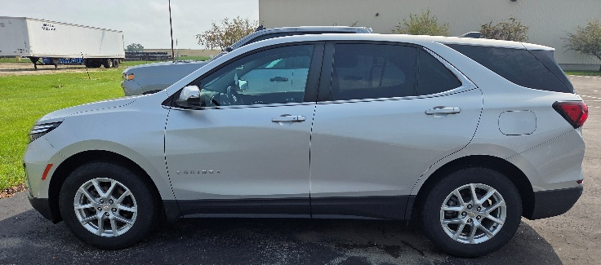

Please contact our office to view vehicle,
By appointment only!

Please submit sealed bid with name, address and phone number by 4:00 p.m. Friday ~ October 30, 2026

Auglaize SWCD – Equinox Bid
110 Industrial Dr #G
Wapakoneta, OH 45895

Bids will be opened around 10:00 a.m., Wednesday, November 4th during the SWCD board meeting at 110 Industrial Drive, Wapakoneta, Ohio. The SWCD reserves the right to reject any and all bids.

Auglaize Soil and Water Conservation District
Board of Supervisors

Name
Address
City State Zip
Phone Number

Bid Amount $

